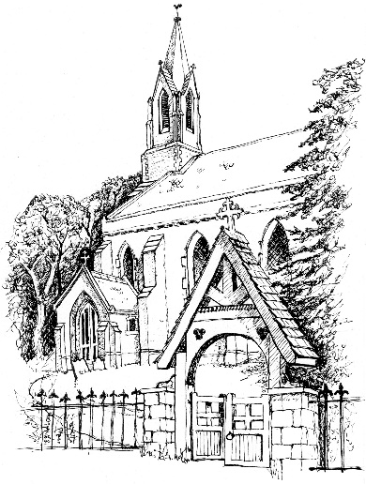
St Philip & St James’ Church, Whittington, Worcester WR5 2RQ
ELIZABETHAN ROOM
Please contact the Booking Adminstrator:
Mrs Caroline Mayfield Tel. 01905 764822 caroline.mayfield40@gmail.com

User Agreement

User . . . . . . . . . . . . . . . . . . . . . . . . . . . . . . . . . .
(Must be 21 or over)
Contact Name: . . . . . . . . . . . . . . . . . . . . . . . . . . . . . . . . . . . . . .
Address: . . . . . . . . . . . . . . . . . . . . . . . . . . . . . . . . . . . . . . .
. . . . . . . . . . . . . . . . . . . . . . . . . . . . . . . . . . . . . . .
Tel. No: . . . . . . . . . . . . . Mobile No: . . . . . . . . . . . . .
email: . . . . . . . . . . . . . . . . . . . . . . . . . . . . . . . (For confirmation of booking)
Date/time of use: Date: . . . . . . . . . . . . . . Start time: . . . . . End time: . . . . . .
Purpose of use: . . . . . . . . . . . . . . . . . . . . . . . . . . . . . . . . . . . . . .

There is no hire charge for the use of the Elizabethan Room; however we would ask that you make a donation to Whittington PCC towards the maintenance and heating costs

NB There will be no heating available between May & September except in exceptional circumstances

I agree to abide by the terms and conditions of use. (The terms and conditions can be viewed on our website – www.whittingtonchurch.co.uk )
Signed: . . . . . . . . . . . . . . . . . . . . . . . . . . . . Date: . . . . . . . . .

email the completed form to the Booking Administrator caroline.mayfield40@gmail.com
OR deliver it to Whittington Church, marked for the attention of the Booking Administrator

Notes
(1) If there is any query, please contact the Booking Administrator (email or tel. 01905 764822).
(2) Any damage found or caused, or anything not working as it should, must be reported to the Booking Administrator.
(3) Cleaning is carried out fortnightly. If necessary, floors should be swept and left clean for the next user.
(4) All rubbish, including empty bottles, drink cans, food scraps, cardboard and other waste must be removed from the room and may be disposed of in the appropriate bin in the Churchyard
(5) Access to the facilities is made by arrangement with the Booking Administrator

September 2022

